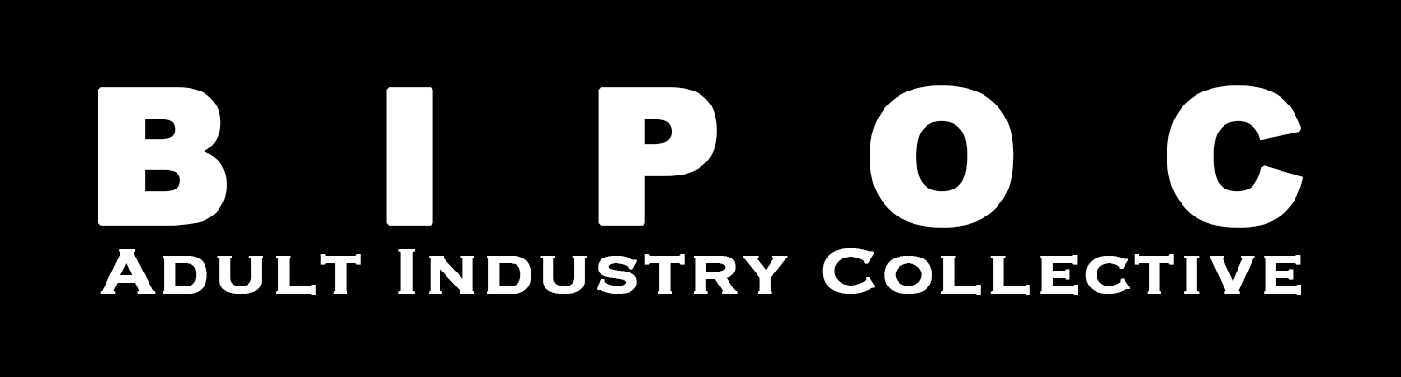

BIPOC Adult Industry Collective
Community Agreement & Values

- Anti-blackness: We do not tolerate any anti-blackness, colorism. Black, Indigenous, and People of Color come in all shades and we celebrate them all.
- Centering of Black & Brown Voices: As BIPOC people often experience tokenism and are overlooked in public and private spaces, we are committed to centering those voices in our work.
- Misogynoir: We acknowledge ways in which the intersection of anti-blackness and sexism Black women experience in private and public impacts their well-being. Our duty is to provide a space in which Black women can feel safe from this behavior. Transmisogyny will not be tolerated, period.
- Fatphobia: We welcome fat folks and fatness without hesitation. We will not judge one another based on unrealistic, European standards of commercial beauty.
- Transphobia: We use pronouns that people have asked us to use. We accept all trans-, non-binary, gender non-conforming, and two-spirited people however they define themselves.
- Xenophobia: We do not judge each other based on place, space, country, immigration status, or expression of culture.
- Homophobia and Biphobia: We acknowledge that sexuality is a spectrum. We are inclusive of all forms of queerness and celebrate everyone regardless of who they fuck.
- Sexism: We do not discriminate based on how one expresses their gender or sex. Stereotyping based on gender or sex has no space in a space dedicated to community organizing.
- Whorephobia: We believe all sex workers are created equal and reject any false hierarchy based on the criminalization of their work and where they ply their trade.
- Ableism: We accept and embrace all body and intellectual contributions to this space. We celebrate differences.
- Poor shaming: We know that one’s contribution to the capitalist monetary system of the U.S. is not an indication of one’s worth. We do not, in practice or in rhetoric, shame or chastise anyone because of the ways they are forced to partake and/or contribute to this construct, or the ways they are disenfranchised by them.
- Dependent status: We acknowledge that Black folks take care of each other. We celebrate the fact that members of our extended community and our duties to take care of each other does not mean we have more or less to contribute to the Collective. We make space for one another to put caregiving over agenda, always.
- Ageism: We acknowledge that age and phase of life do not overdetermine one’s capability or ability to contribute to the decolonizing porn. Wisdom comes from youth and elders alike and will always be respected as such.
- Centering Black & Brown Voices: As BIPOC people often experience tokenism and are overlooked in public and private spaces, we are committed to centering those voices in our work. We are committed to working with BIPOC whenever possible.
- Financial Empowerment: We believe sex is work and the key to financial empowerment is putting money directly into the hands of sex work. In cultivating our initiatives we will always ask ourselves, “will this put more money directly into the hands of sex workers?” “Will we make Sex Workers safe by doing this work?” We will take a harm reduction approach to all work will do, meeting people where they are to provide them with what they need rather than what we think they need. When giving money directly to sex workers, we will not govern or dictate how the money must be used. We are here to help, that’s all.

Values

Take space and make space: Those of us who take space are encouraged to make space when they would ordinarily share. Those of us who make space are encouraged to take space when they wouldn’t ordinarily share. You are encouraged to say what needs to be said. During meetings, you are encouraged to ask yourself these questions: Does this need to be said? Does this need to be said by me? Does this need to be said by me right now? And/or: Why do I feel the need to keep what needs to be said aloud inside me? Can I take a risk? What are the benefits? How do I release any expectations of myself steeped in whiteness, respectability, and perfection to be, look or sound a way other than what I showed up as (with respect to the agreements.) Taking space and making space can look/feel/be different based on the multiplicity of intersecting identities, particularly with regard to race, gender, sexuality, size, and various relationships to education, knowledge, and ways of knowing. That is okay. I trust that folks will make space for nuance. This is a space for BIPOC people to speak freely and have their ideas met with support.

We will honor and use folks’ correct pronouns. We won’t ask intrusive questions around folks’ gender. We will make every effort to get them right and when we fuck up, we will make every attempt to correct and make amends without centering one’s self. Pronouns are not a preference. If this is and feels new to you, be patient with yourself but make every effort. It may require that you slow down, especially when talking. That is okay. Misgendering happens. But when it happens, it is not a ‘mistake’. It is learned behavior that can be unlearned. It is a symptom of colonial, capitalist, gender violence and we have to learn to do better and be better.

We will respect the bodily/autonomy of every person and make every attempt to listen and improve with correction if we harm. We will not put our intentions, wants, and desires before the needs of others. We will not touch folks without permission when in-person with one another. We will not send unsolicited nudes. We will ask for an enthusiastic yes in touching another person both within the collective and in our personal lives. We trust folks to decide what boundaries to assert and hold for themselves. We respect the words “no,” “I don’t know,” “maybe,” and “not right now” to mean “no.” We will not treat folks differently when they say no. We will not interrogate folks’ no. We will not question folks’ no. We will respect folks’ no. We will not use, violate and
weaponize our different or shared identities and subject positions in the world to coerce folks into a yes and to make excuses for engaging in the touch (of any kind) with/of others. Boundaries are not exclusive to the body, touch, or physical. They can include verbal (and many) other forms of unwanted contact.
We will respect boundaries.

We will ground our understanding of our own embodied experiences and varying knowledge. In this space, we hold up the knowledge we have acquired from varying sources and methods. We acknowledge that institutional learning is no better-lived experience and will not treat others differently based on their ability or experience in academia. It is ok to be at a different point in your learning or political development than other participants. We are here to build collective knowledge through sharing from where we are.

We see learning as political education and essential to revolution. We understand that there is more work to be done but hold space for the work we are doing to learn amongst our own, question amongst our own, and build an intentional community.
We will understand and hold space for individual and collective feelings - and various expressions of feeling (as long as it is not harmful). We acknowledge that we are gathering during an extraordinary trying time. Sometimes being in a community means sitting in discomfort, as we share our stories, with the understanding that this work may be challenging and everyone needs to be supported to do the work. At the same time, please take personal breaks, as needed. If you need assistance in accessing mental health resources, please notify one of the collective members so we can do our best to help you find what best serves you.

